**Application Building**

|  |  |
| --- | --- |
| Team Id | PNT2022TMID07306 |
| Project Name | AI-powered Nutrition Analyzer for Fitness Enthusiasts |

In the flask application, the input parameters are taken from the HTML page These factors are then given to the model to predict the type of food and to know the nutrition content in it. In order to know the nutrition content. we will be using an API in this project.

**Create HTML Pages:**

* We use HTML to create the front-end part of the web page.
* Here, we have created 7 HTML pages-dashboard.html, login.html,

predicition.html , imageprediction.html , bmr.html, bmi.html, diet.html.

* dashboard.html displays the home page.
* prediction.html is used for uploading the image
* prediction.html will showcase the output
* prediction.html is to showcase the result. It tells the action to be performed on imageprediction.html while showcasing the result.
* We also use JavaScript-main.js and CSS-main.css to enhance our functionality and view of HTML pages.

1. Login Page

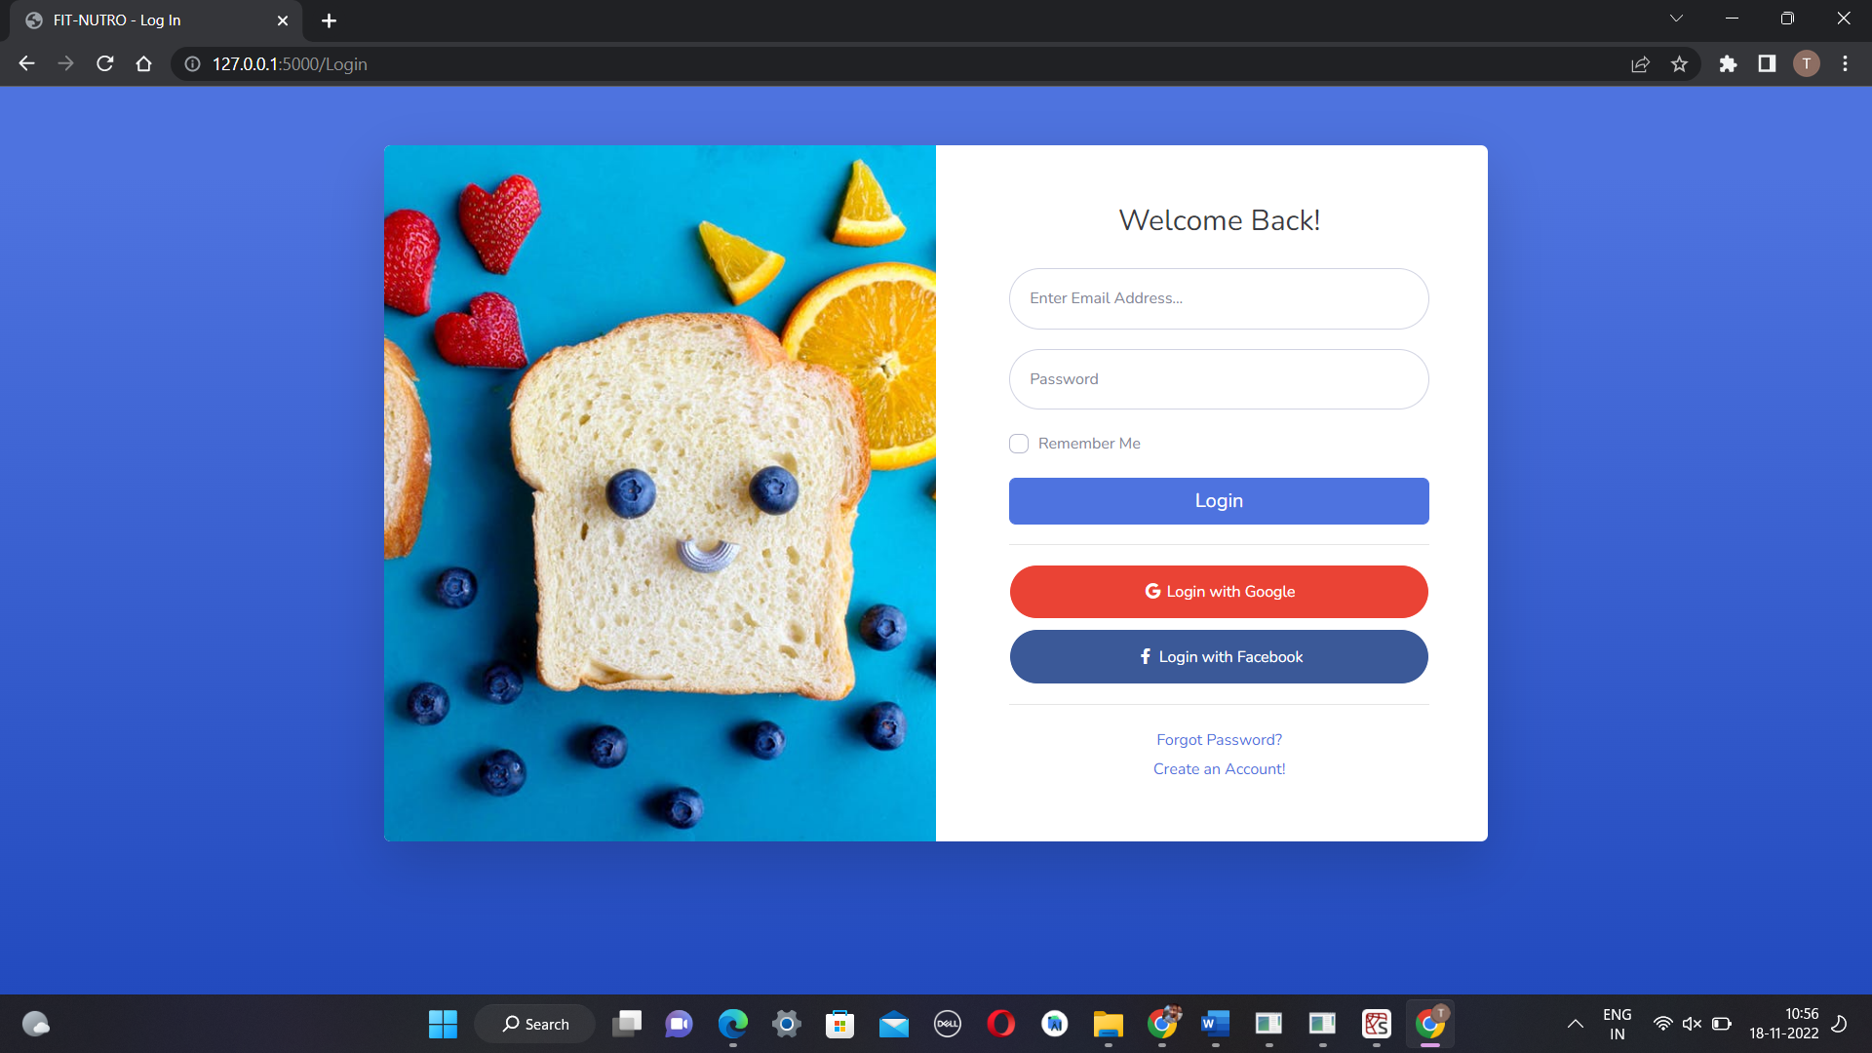

1. Registration Page

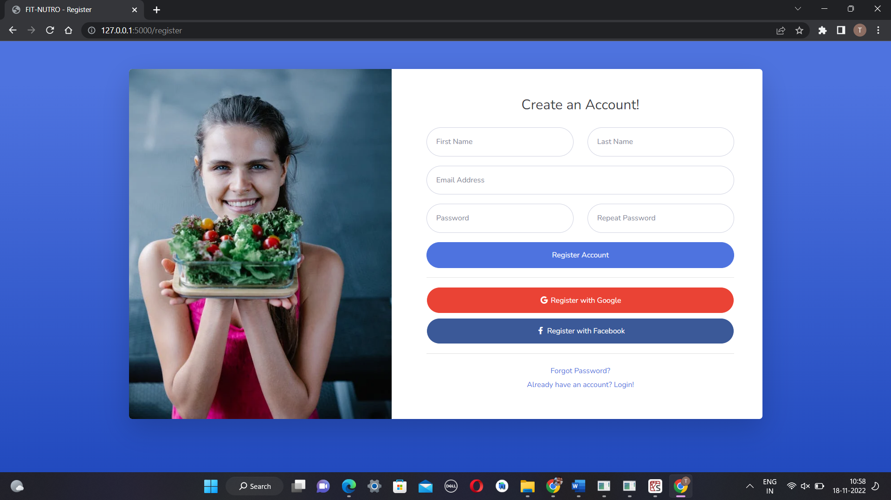

3.Forgot Password Page

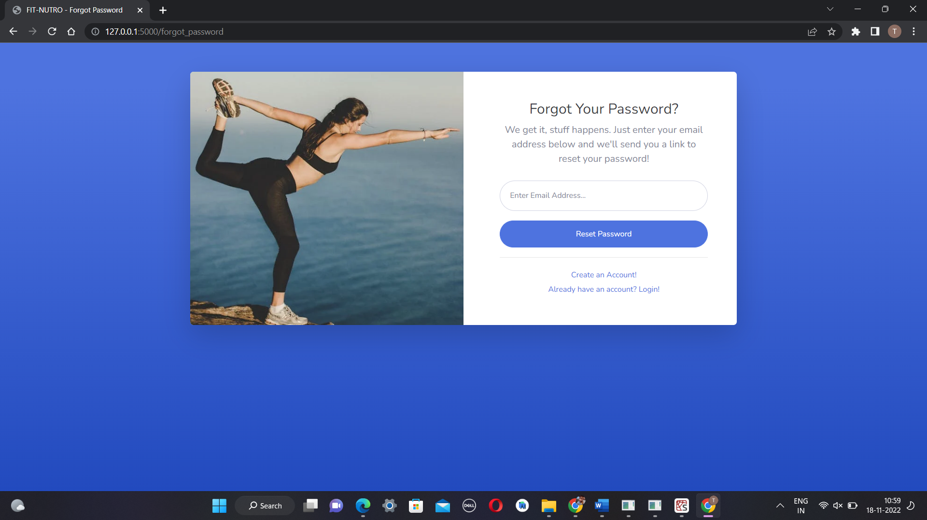

4.Dashboard Page

5.BMI Page

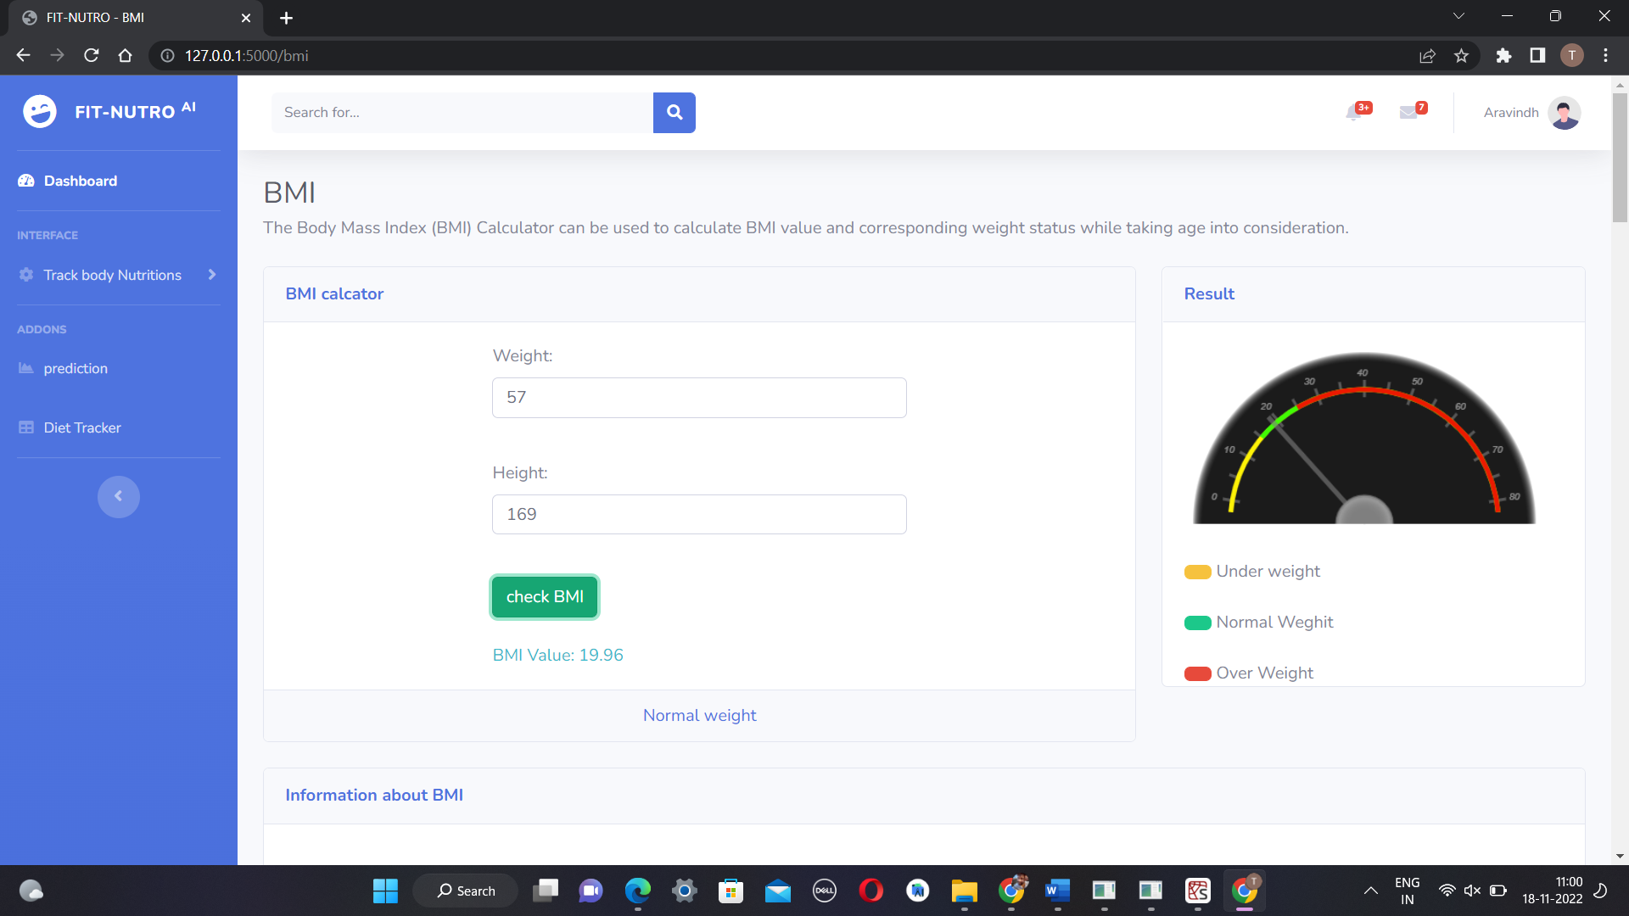

6.BMR Page

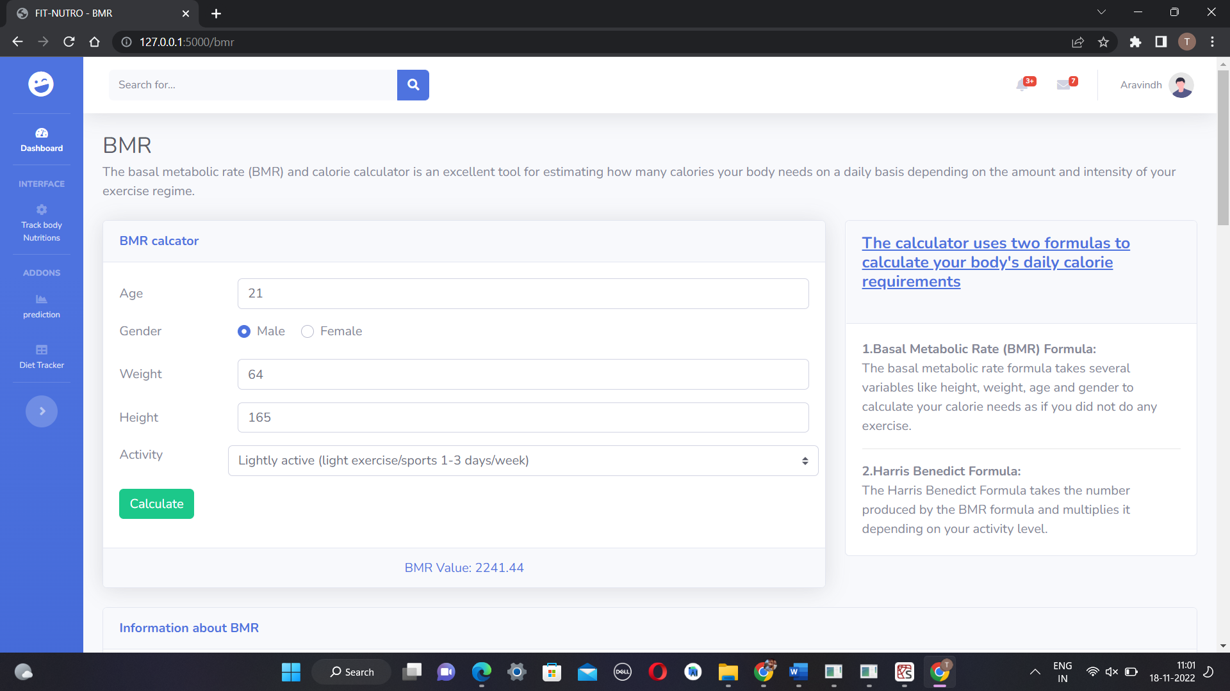

7. Diet Tracker

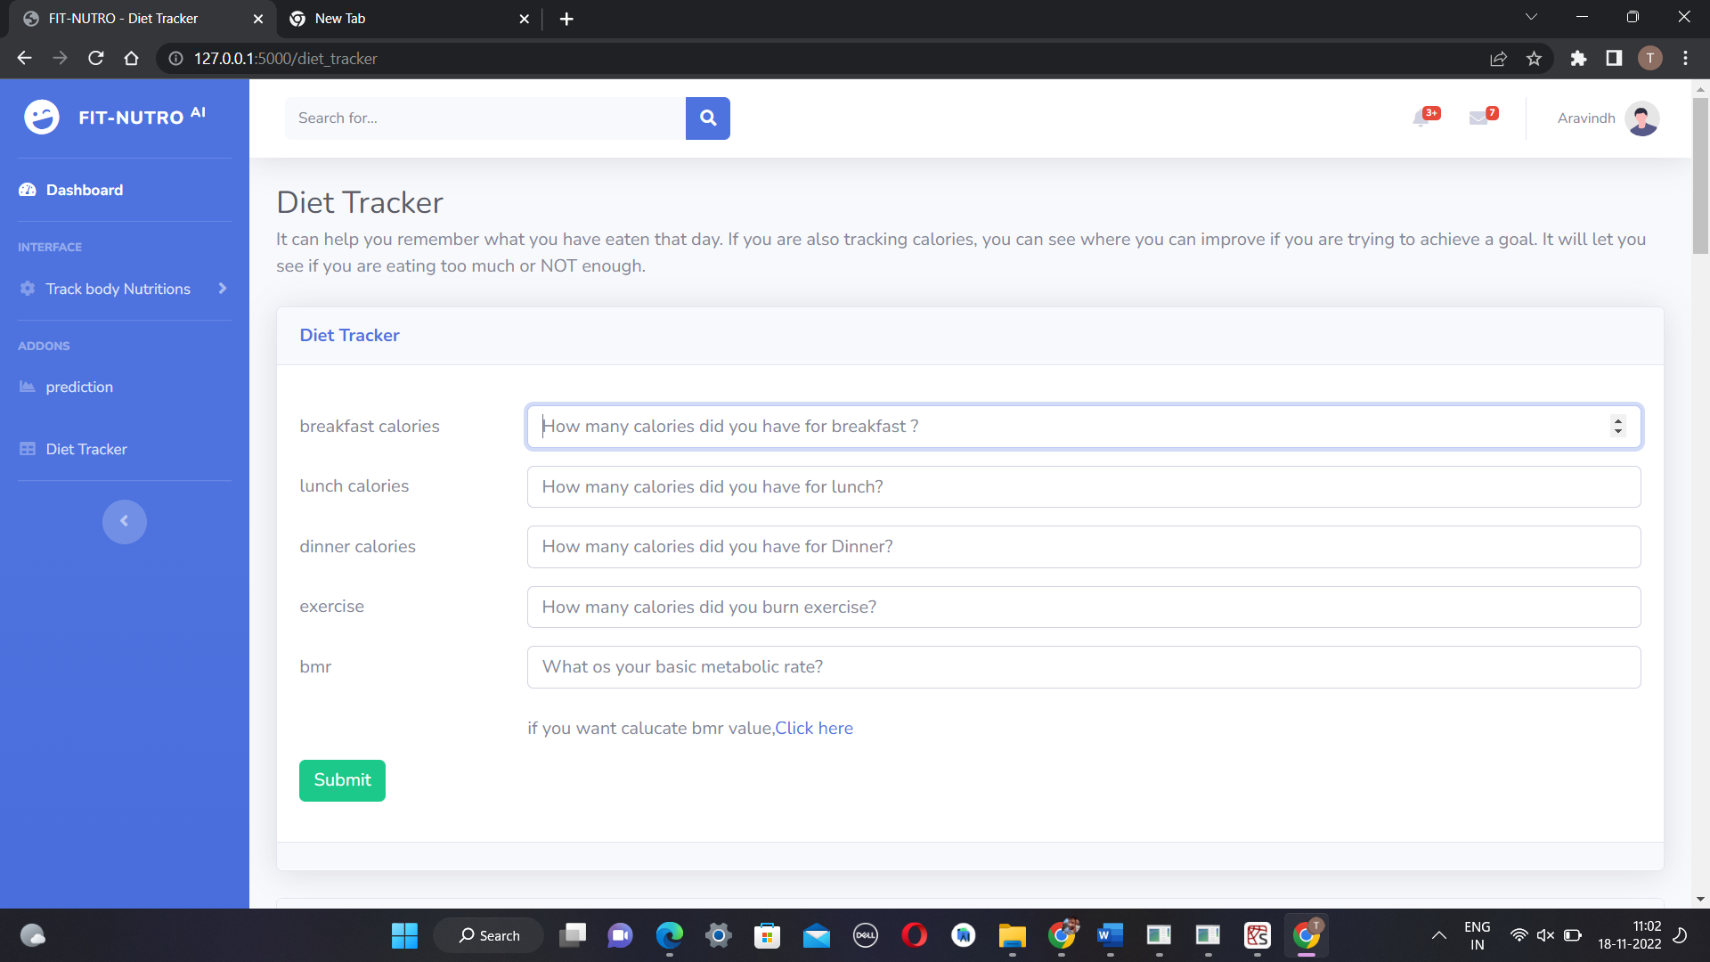

8. fruits and vegetables classification